PO Aging Report:
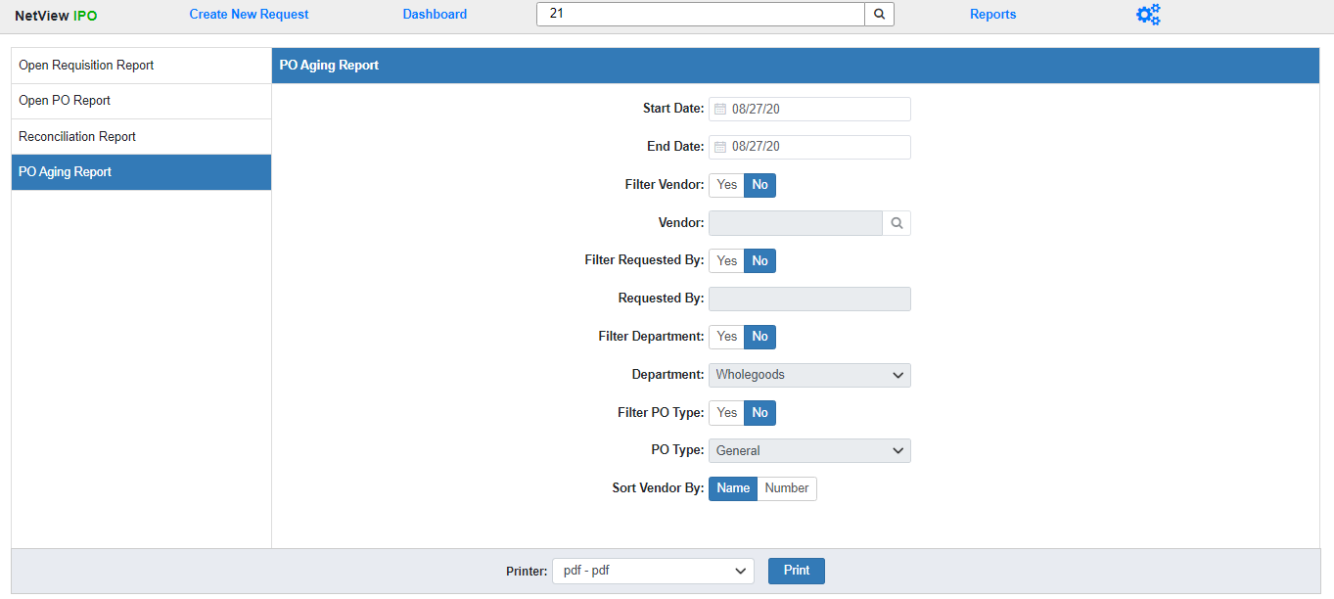
The PO Aging report lists all your Open POs with creation dates in a set time period, and indicates how long they have been open, as measured by 30-day aging periods. You can use the fields displayed to run the report for specific items, such as viewing all the Open POs for a single vendor or for a specific Department.
Field Definitions:
Start/End Date: Enter the start and end dates for your desired time period. The report will include all Open POs created during that time period. Both fields default to the current date.
Filter Vendor: Select Yes to run the report for all Open POs belonging to a specific vendor. Select No to run the report for all vendors.
Vendor: This field will activate if you choose to filter the report by vendor. Enter the Vendor Number you wish to run the report for or use the Search option to look it up by entering part or all of the vendor’s name.
Filter Requested By: Select Yes to run the report for all Open POs created by a specific user. Select No to run the report for all creation users.
Requested By: This field will activate if you choose to filter the report by the creation user. Enter the desired user’s ID here. NOTE: If the ID you enter doesn’t exist in the system, you will receive a blank report.
Filter Department: Select Yes to run the report for all Open POs belonging to a specific Department. Select No to run the report for all Departments.
Department: This field will activate if you choose to filter the report by Department. Select the desired department from the drop-down menu. The options will be all Departments that currently exist in your system.
Filter PO Type: Select Yes to run the report for all Open POs with a specific PO Type. Select No to run the report for all PO Types.
PO Type: This field will activate if you choose to filter the report by PO Type. Select the desired type from the drop-down menu: General, Unit, or Part.
Sort Vendor By: The report is sorted by the PO Vendor, and lists both the Vendor Name and the Vendor Number. Use this option to select if you want the report sorted by Vendor Name or Vendor Number. The report sorts by Vendor Name by default.
Printer: Select the printer to receive the report. Use the pdf printer to view the report before printing.
Click “Print” to run the report.
Sample Report:
[KEEP GOING ONCE BUGS FIXED]
[ADD IMAGE ONCE FIXED]
The report is divided into sections by vendor, with each section beginning with a line listing the vendor number and name.
Report Columns:
PO Number:
Date:
Department:

